Since January 2021, the Karaganda Higher Polytechnic College has implemented the International Project “Erasmus+”: “Implementation of the dual system in Kazakhstan / KAZDUAL”. The project involved social partners OLDI MAX LLP, Alma Telecommunications Kazakhstan JSC, TransTeleCom JSC, Kazteleradio JSC, Kaz Post JSC, Svyaz Plus LLP, KaragandaEnergoCenter LLP.
To improve the quality of dual education at the college, a tremendous amount of work was carried out with enterprises and companies, and a plan was developed for organizing the educational process within the framework of a tripartite agreement between the college, the enterprise and the student in accordance with regulatory legal acts.
For three years in a row, in the month of April, the KVPTK hosted an International Scientific and Practical Conference together with the KAZDUAL project. The organizers and participants of the International Scientific and Practical Conference were teachers of the Karaganda Higher Polytechnic College, the Department of Education of the Karaganda Region, teachers of the Karaganda University. Academician E.A.Buketov, research fellows of Otto-von-Guericke University
(Federal Republic of Germany), representatives of the project from the funds of the Federal Ministry of Education and Science of Germany, under the patronage of the German Aerospace Center, the Project Management Agency, the working group “Internationalization of Vocational Education”, representatives of the KAZDUAL project from the funds of Erasmus+ / EACEA of the European Union.
On April 21-22, 2021, at the Karaganda Higher Polytechnic College, in the year of its 90th anniversary, an International Scientific and Practical Conference was held on the topic “Competence Center - new opportunities for the development of a system of technical and vocational, post-secondary education (TVET).” Link to information about the inter-row conference: https://kvptk.edu.kz/ru/post/mezhdunarodnaya-nauchno-prakticheskaya-konferenciya-centr-kompetencij-novye-vozmozhnosti-dlya-razvitiya-sistemy-tehnicheskogo-i-professionalnogo-poslesrednego -obrazovaniya-tippo

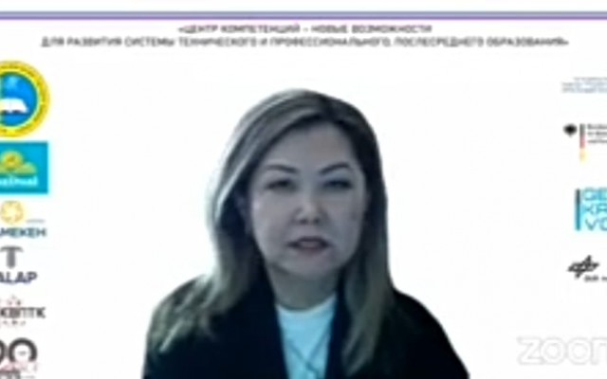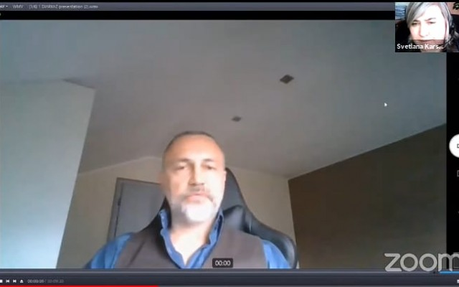

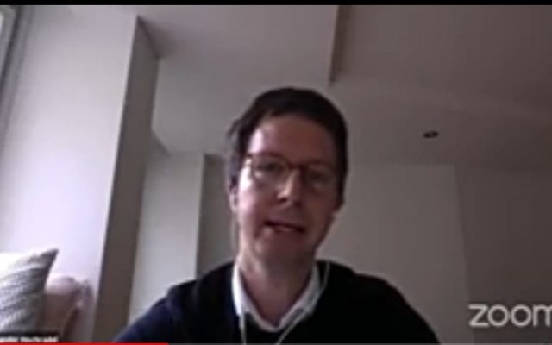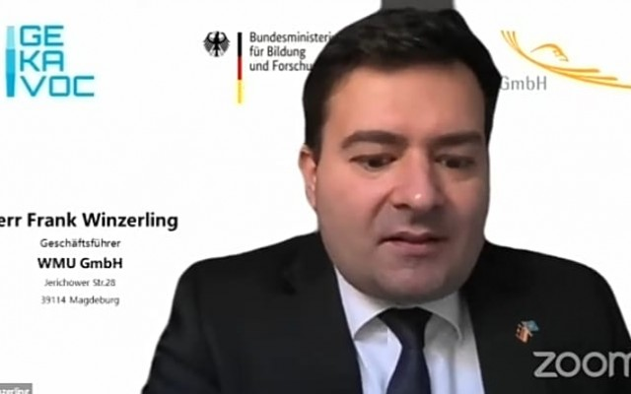
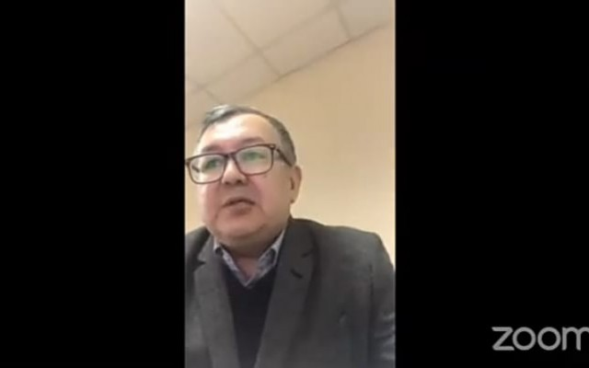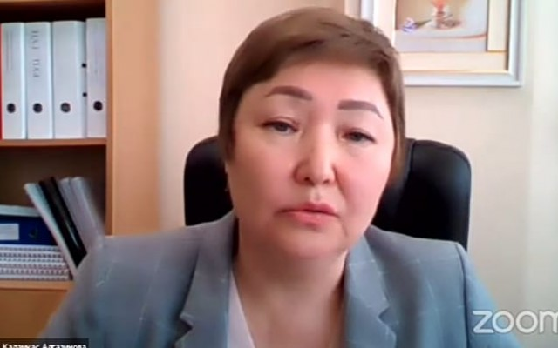

September 22, 2022 on the basis of Karaganda University named after. Academician E. A. Buketov, within the framework of the international project KazDual “Implementation of the dual system in Kazakhstan” of the Erasmus+ program, training sessions are being held on creating learning situations. Yulia Nepomashchaya, trainer at the University of Magdeburg (Germany), presented 32 methods of professional training. Participants got acquainted with technologies for organizing learning situations. Each team of participants developed and presented methods for dual training. Experts from the Pedagogical University of Tyrol (Austria) Ingrid Hotarek and Mario Watch presented “Pedagogical approaches to teaching in dual education.” During the conference, national coordinator of the project Bayan Sapargalieva, Abai University, spoke about the progress of the KazDual project “Implementation of the dual system in Kazakhstan”, Vice-Rector for Academic Affairs of M. Auezov SCU Roza Abisheva made an online presentation “Formation of competencies through the dual education system: experience Auezov Universuty".
In the afternoon, team members went on an excursion to the QazTehna plant. Plant specialists spoke about their experience of working with students of dual programs of Karaganda University named after academician E.A. Buketov and Karaganda Higher Polytechnic College. Participants were interested in the experience of organizing and supporting mentoring and motivating dual trainees.
For reference: “QazTehna” is a modern, high-tech, environmentally friendly production of passenger buses and electric buses, mining, construction and road equipment in Kazakhstan that meets international quality standards.

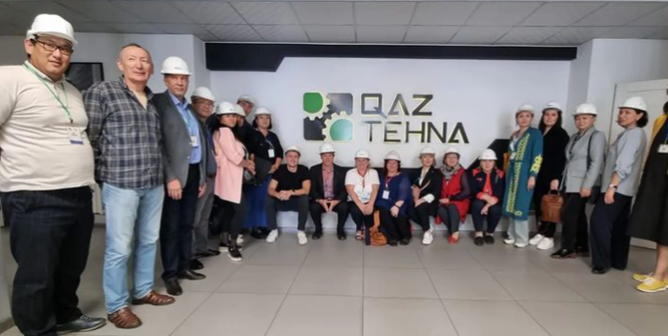
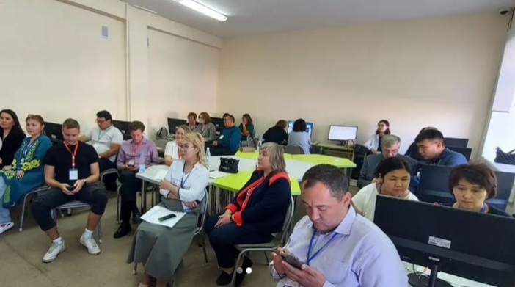

On October 6, 2022, a parent meeting was held on the implementation of the dual system and the conclusion of agreements with educational enterprises with group 9-TEU-22, which was attended by Deputy Director for Educational and Industrial Work Kovalev A.A., Head of the Department of Energy Disciplines O.V. Shelikhovskaya. , teacher of special disciplines Amantaeva A.S. Also present at the meeting were representatives of enterprises with which agreements were concluded on VSA Glukhov S.S. JSC "KaragandaEnergoremont", Berezhnoy N.A. KTMZ LLP, Dyusembekova Zh.K. Karaganda Energy Center LLP
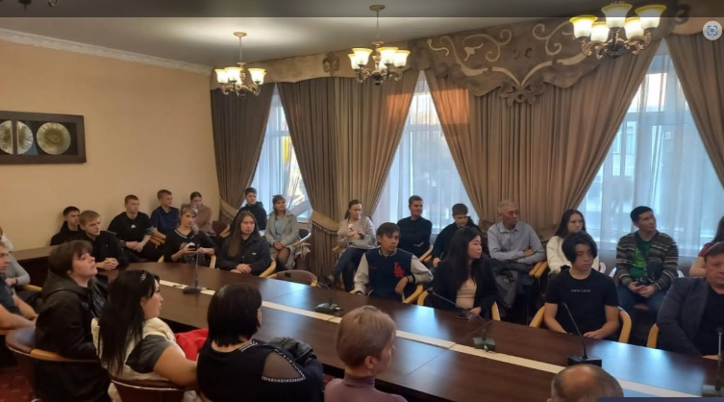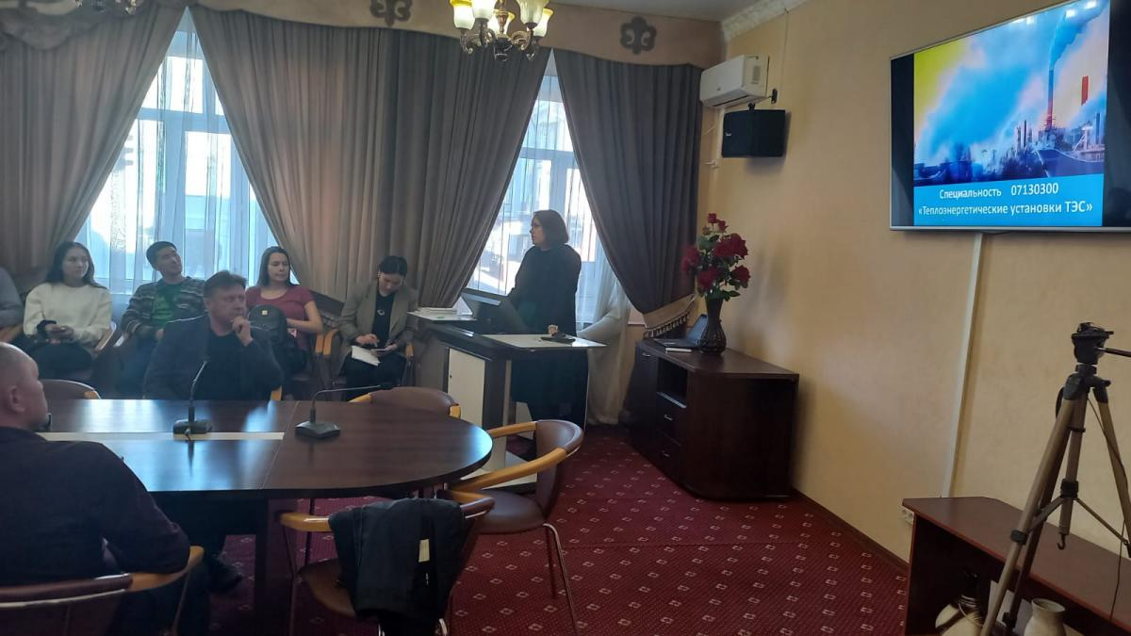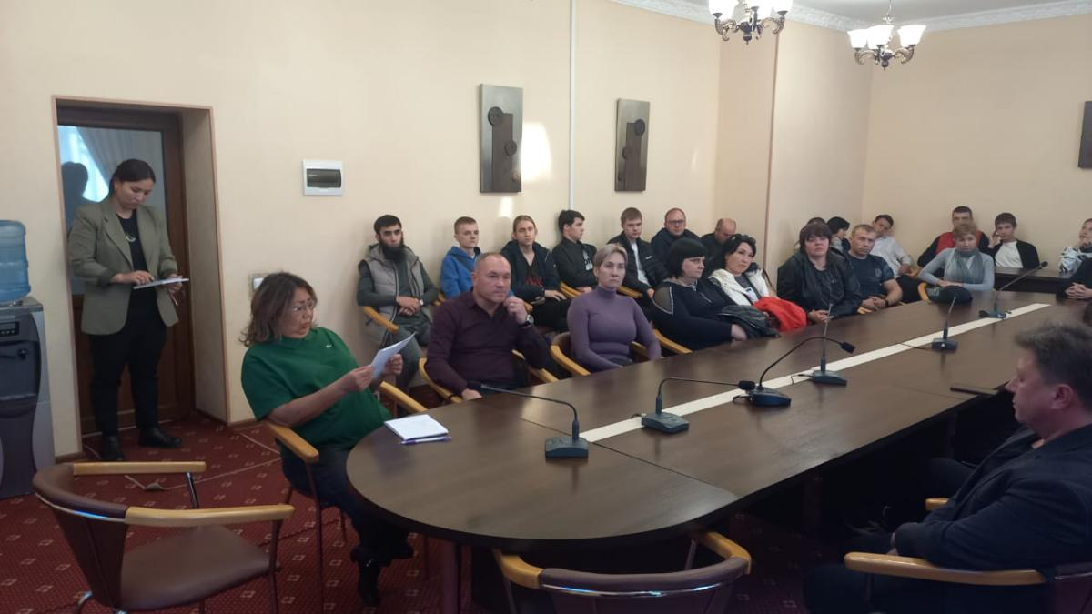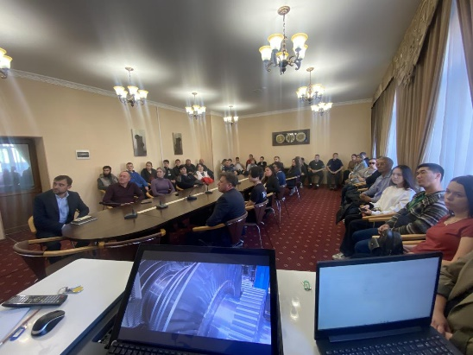

In the spring of 2023, the Karaganda Higher Polytechnic College was accredited as a pilot dual program. Social partners, teachers and students of the accredited specialty took part in the accreditation.
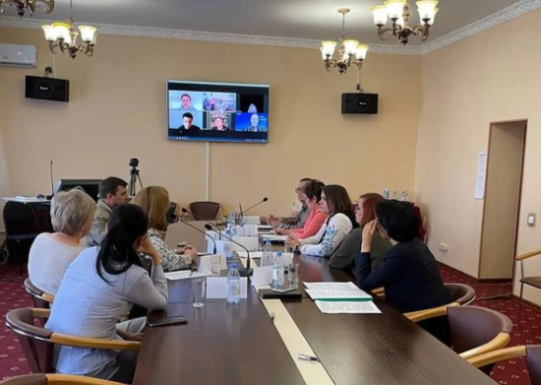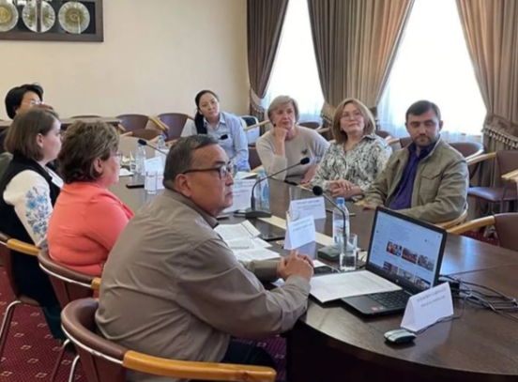

In September 2023, a working group (Aubikirov G.D., Takshylykova D.R.) from the Karaganda Higher Polytechnic College conducted training seminars at 12 departments on the topic “KAZDUAL - “Implementation of a dual system in Kazakhstan.” The participants of the study tour were familiarized with the specifics of the implementation and organization of dual education in Germany, with the advantages of this approach in general; moreover, the participants had the opportunity to ask questions of interest, as well as discuss the types of dual education directly with the drafters of work plans and representatives of large enterprises who have successfully introduced dual training methods into their practice. In particular, the transfer of experience from Germany and Kazakhstan was very fruitful and will be useful for solving the upcoming tasks of the project.

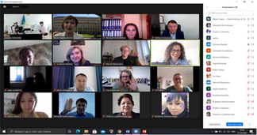

In order to effectively use the experience of advanced foreign countries in the field of introducing dual education, from November 6 to 11, the delegation of the Karaganda Higher Polytechnic College, headed by director Rakhimova Zh.Z, at the invitation of the Otto von Guericke University of Magdeburg, went on a working trip to Germany.
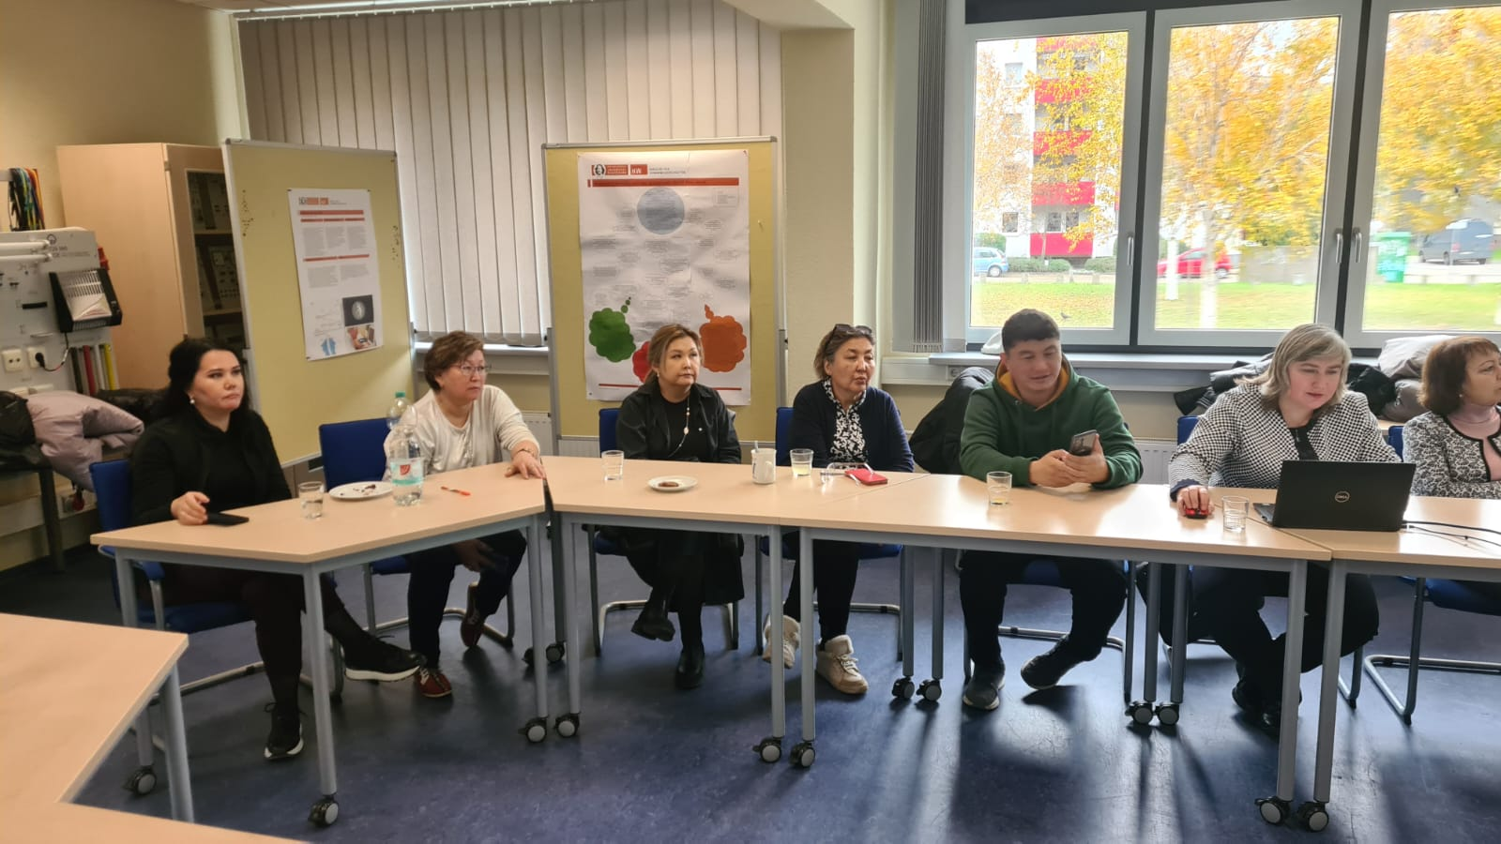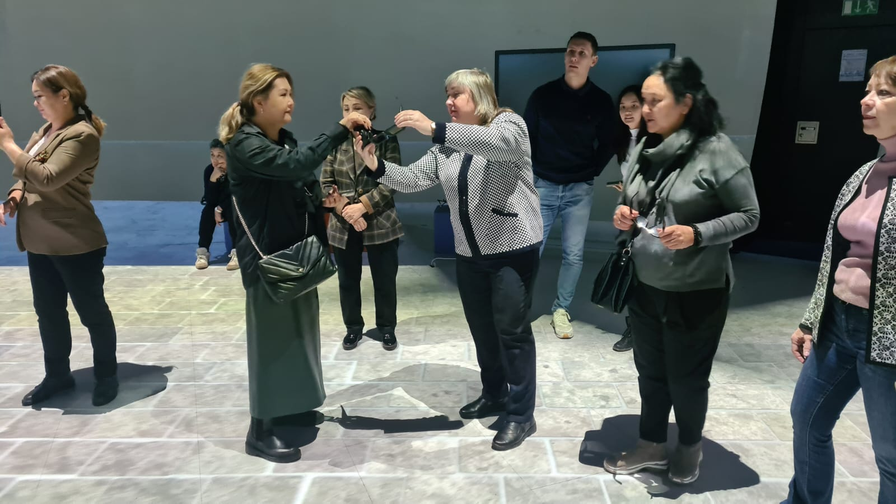

On November 16, 2023, the International Scientific and Practical Conference was held at KVPTK together with the KAZDUAL project. The organizers and participants of the International Scientific and Practical Conference were teachers of the Karaganda Higher Polytechnic College, the Department of Education of the Karaganda Region, teachers of the Karaganda University. Academician E.A. Buketov, researchers from Otto-von-Guericke University (Federal Republic of Germany), representatives of the KAZDUAL project from Erasmus+ / EACEA funds of the European Union.

On December 05-07, 2023, a conference was held at the Abai KazNPU dedicated to the completion of the international project KAZDUAL on the introduction of a dual education system into educational institutions, where project partners from Kazakhstan, Austria, Germany, and Estonia took part.
This large-scale event was attended by the director, deputy directors, and leading teachers of the Karaganda Higher Polytechnic College.
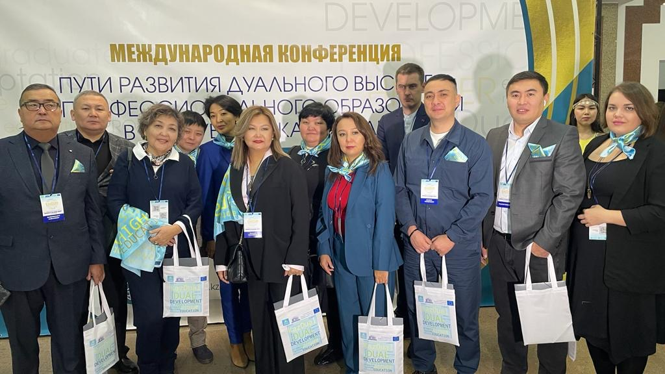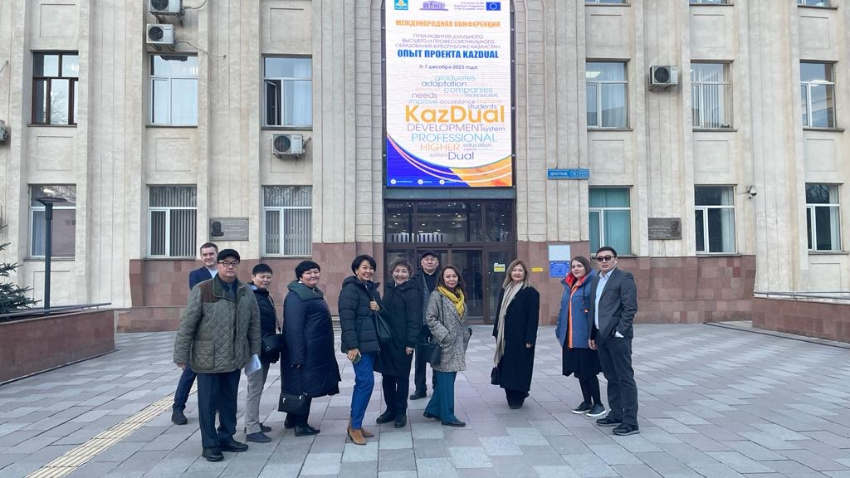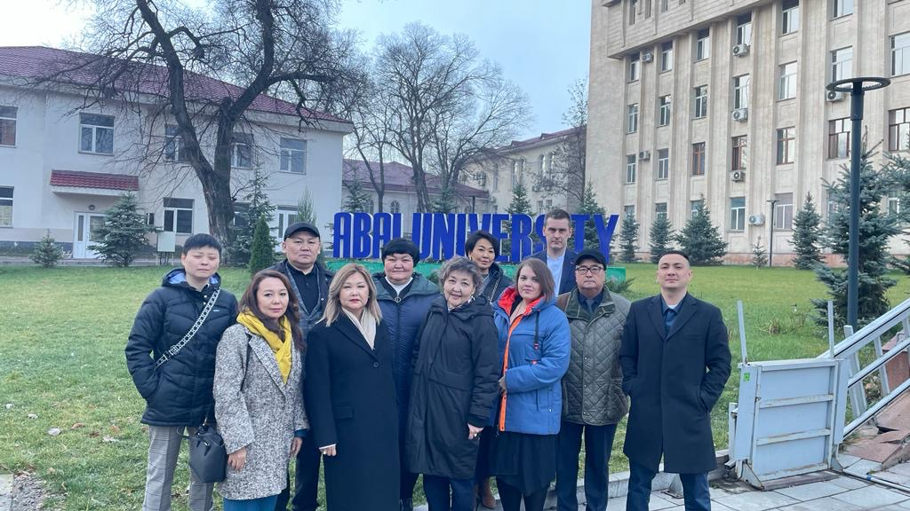

The pedagogical council was held on 02/08/2024 for 245 KVPTK teachers, to whom information was provided on the results of the project, including data on the quality of education, the level of satisfaction of participants, and improvement in educational indicators.

Visits by the pilot group in the period 2022-2023 to energy enterprises in the region, repair enterprises and energy saving activities.
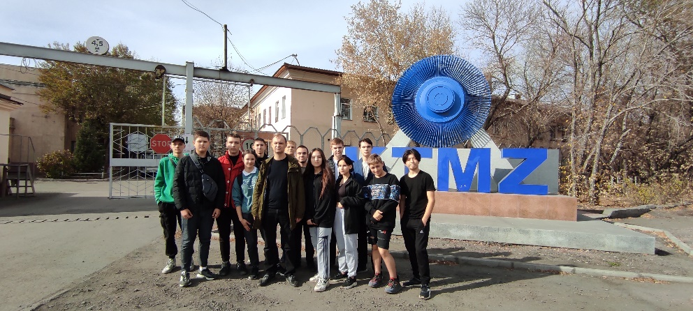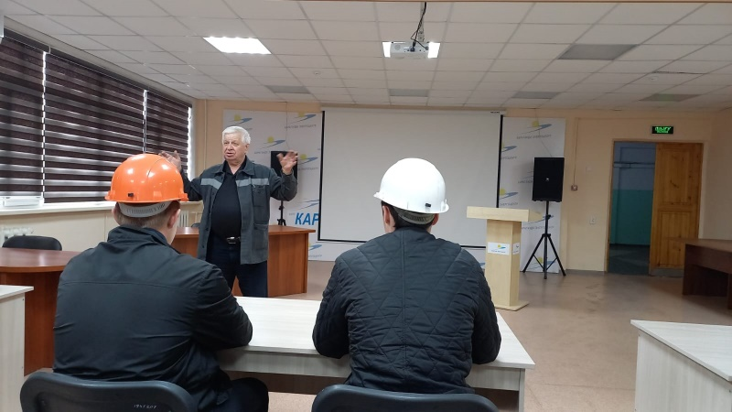
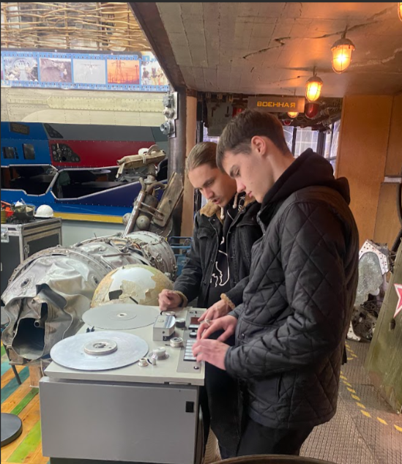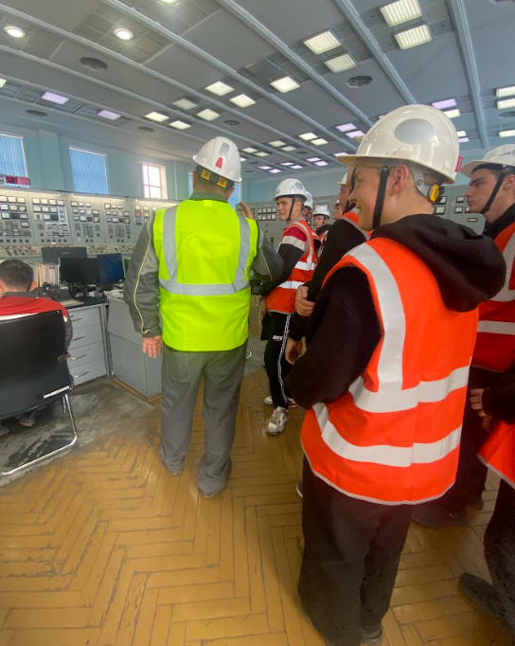
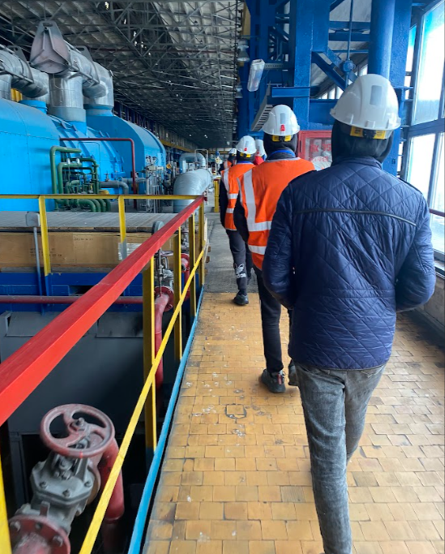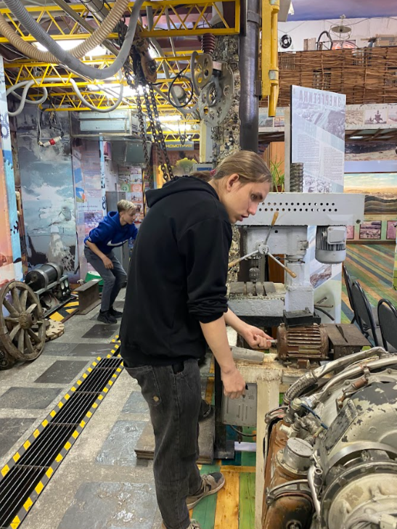
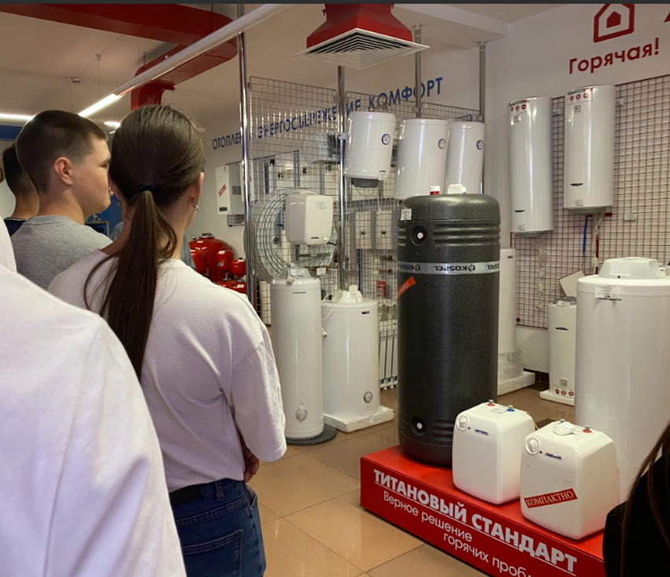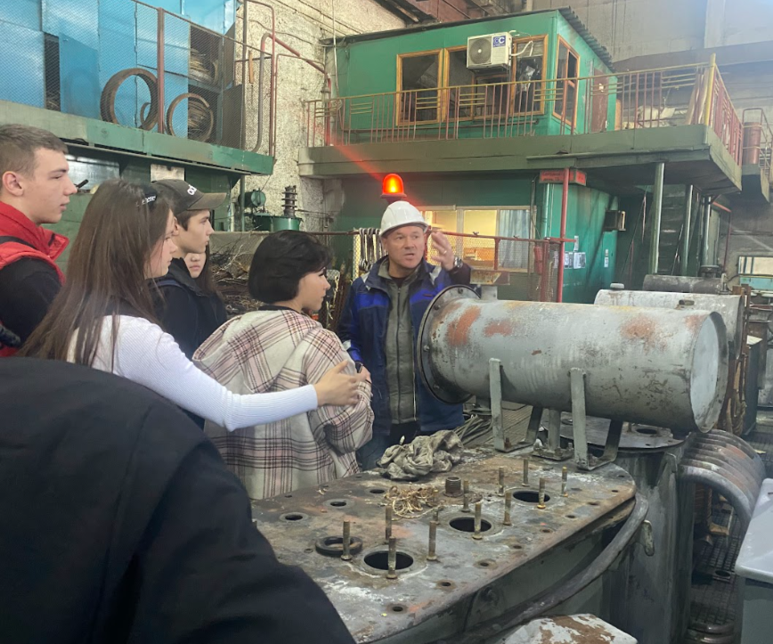
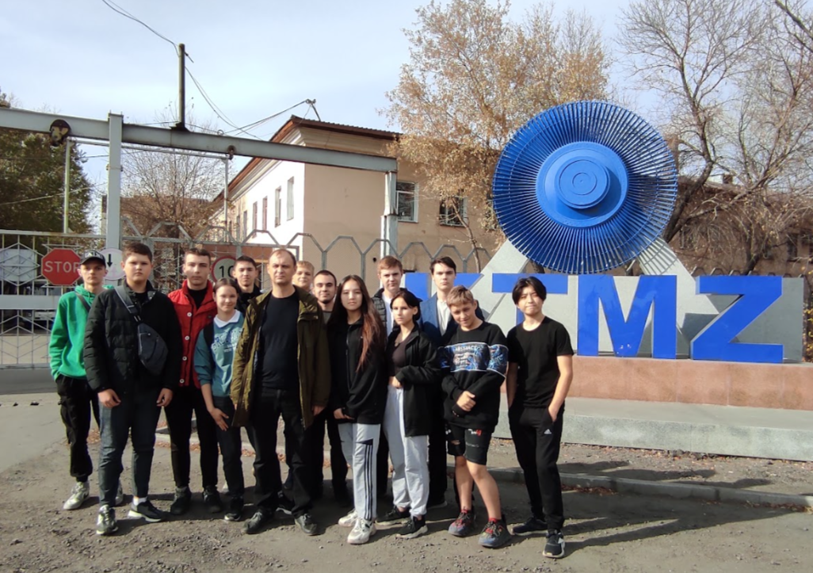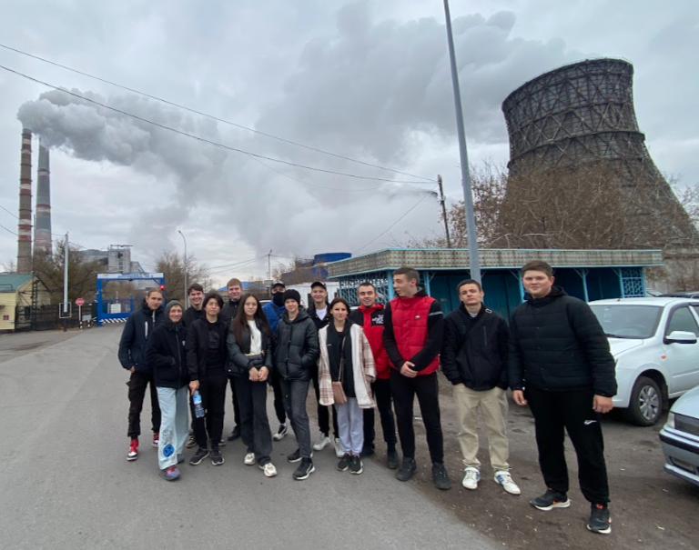

An internship in welding and a competition based on the results of the internship in the fall of 2023 showed excellent results, and students also completed an internship in automation.
